**Design of Sewer System**

Khan Sameera, Khan Mohd Husainb, Khan Ashrafc, Jain Kunald

Thinakaran Ee, Dr.Ananth KRf

a,b,c,d,eRizvi College Of Enginerring, Mumbai,

fVelalar College of Engineering and Technology, Erode

*asamer.sk672@gmail.com, biamhussaink@gmail.com, d*[*jain78162@gmail.com*](mailto:jain78162@gmail.com)*, ethinak8@gmail.com,fkmrananth@yahoo.com*

**Abstract:** The paper is based on design of one of the optional sewerage system for carter road, Bandra in Mumbai. The design aims at effective abatement of pollution by providing a comprehensive waste water collection, treatment and disposal system using laterals, branches and main lines. Since present sewage system are old and sometime not very efficient designs of new sewerage system. The design done here covers the entire area between the loop and neighboring area and the population within the loop and also the population of neighboring areas. In this paper, the design a sewer system for Carter road, Bandra, Mumbai has been carried out using EPANET and manual calculation.

**Key Words***: Sewer, EPANET, Invert Level.*

**1. INTRODUCTION**

Nowadays in urban cities it is necessary to maintain hygiene of city. To achieve sewage generated from the societies/colonies are to be disposed in the proper means, such away it doesn’t mix with the potable water. There is a special system of pipe called as sewer system, which carry sewage and sometimes both sewage and storm water to pumping station and final destination to the treatment plants [1]. Storm sewers (a part of a sewage system) carries excess rain water to safeguard the roads from flooding. The underground drainage pipes of the sewerage system in Mumbai are more than 100 years old and needs renovation. In congested parts, the sewerage lines and water pipelines run together and leakages may contaminate drinking water [6]. The unplanned and unauthorized growth of the city makes it difficult and, at times, impossible to replace old sewerage lines. The problem of sewer lines of small diameters, getting choked due to solid waste and silt entering them is rampant. The result is that instead of getting drained, sewage overflows on to the surface [2]. For network design of sewer EPANET software has been used. EPANET is a computer program that performs extended period simulation of hydraulic and water quality behavior within pressurized pipe networks. A network consists of pipes, nodes (pipe junctions), pumps, valves and storage tanks or reservoirs

**2. STUDY AREA**

The study area is located at Carter road, Bandra in Mumbai and this places is situated at an off coast of Arabian sea. At this location heavy rainfall always occur in monsoon which causes sewer to overflow.

**3. METHODOLOGY**

The flow chart 3.1, shows the procedure of designing of sewer which we have carried out.

**Flow Chart: 3.1: Design Procedure**

**Selection of site**

Division of catchment area

Show sewer line system on map

Find present population in each catchment

Calculate Rainfall intensity. Take return period of 25 years

Take Elevation from Google Earth

Forecast population for 3 decades

Calculate Wet weather flow for each catchment

Calculate discharge of every catchment

Add both discharges to get total

Take peak discharge. Take peak factor as 3

Assume self cleansing velocity for full depth

Use Q=AV and find diameter of pipe.

Using manning formula v= $\frac{1}{n}R^{\frac{2}{3}}S^{\frac{1}{2}}$ for finding slope

Calculate the velocity and slope for sewer running ${3/4}^{th}$ full

Calculate invert elevation of each pipe

Detailed survey has been carried out for finding the population of the region. During the survey number of flats, bungalows, chawl rooms and shops have been calculated (Table.2.1). And according to the standard of living, numbers of people per household have been assumed and population data have been generated. The total area under consideration is 14.52 hectors.

Table:2.1: Population Data

|  |  |  |
| --- | --- | --- |
|  | number | People/household |
| Flats | 1484 | 4 |
| Rooms | 245 | 4 |
| Bungalows | 59 | 5 |
| Shops | 43 | 2 |

The growth rate of population is taken as 8.29% per decade and the design period is of 3 decade.

According to the standard of living the water consumption per person is taken as 135 liters of which 80% is converted into sewage. Hence from this it is calculated that the sewage produce per person is 108 liters per day. From which the discharge is calculated considering the 3 as the peak coefficient factor. This is expressed in Table.2.1.

Figure 3.1 shows the layout of the pipe network. The line which is marked in red in the figure 1 is the main pipe line and the remaining lines which are marked in black are the branch line. Figure 1also shows the elevation of nodes which have been marked at every 30 meter and at every change of slope and direction. The elevations have been calculated with the help of Google earth application which gives the elevation with respect to mean sea level. Figure 3. 2 show the distribution of our total area into small number of catchment area. Our total area is 14.52 hectors which is divided into 23 small catchment areas, for the ease of calculation of rainfall intensity.

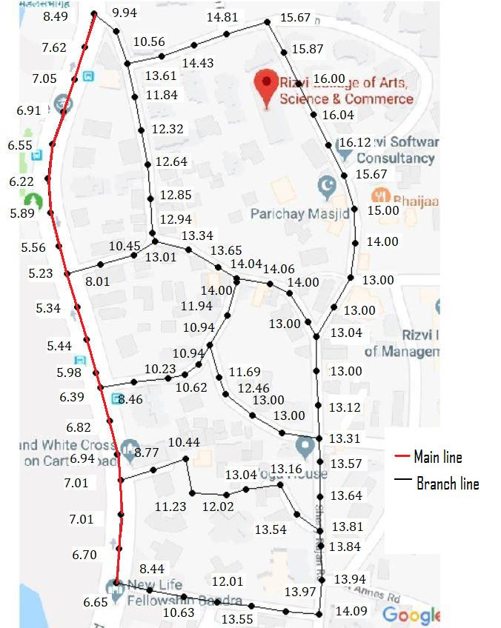 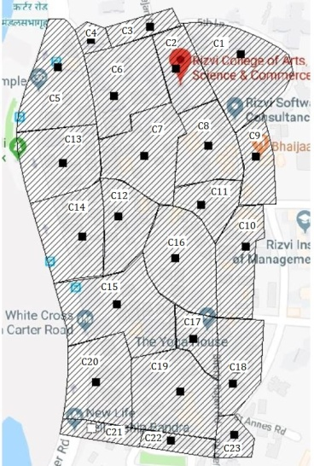

**Figure: 3.2: Catchment Area**

**Figure: 3.1: Pipe Network**

**4.RESULT AND DISCUSSION**

**Rainfall intensity calculation:**

Quantity of storm run-off is dependent on intensity and duration of rainfall, characteristics of catchment area and time required for such flow to reach the sewer. Storm water flow for this purpose can be determined by using rational methods, hydrograph methods or empirical formulae [3].

**Rational formulae:**

Q = 0.00278 PAIc ${m^{3}}/{sec}$

Where, A- Catchment Area in hectares

P- Runoff Coefficient of Runoff

Ic- Intensity of Rainfall mm/Hr

Ic =Io (2/(tc+1))

tc= $({{\frac{0.87L}{H}}^{3})}^{0.385}$

Where, tc Time of Concentration in hour

L- The distance from the critical point to the structure in km

Io – One hour Rainfall

|  |  |  |  |  |
| --- | --- | --- | --- | --- |
| DURATION IN HOUR | RETURN PERIOD IN YEAR   |  |  |  | | --- | --- | --- | | 1 | 10 | 25 | |
| 1 | |  |  |  | | --- | --- | --- | | 29.911 | 65.861 | 76.770 | |

Therefore, Io= 76.770 mm/hour

**Self Cleansing Velocity** - It is necessary to- maintain a minimum velocity or self-cleansing velocity in a sewer to ensure that suspended solids do not deposit and cause blockage. A minimum velocity of 0.8 mps at design peak flow in the sanitary sewers is recommended. So velocity has been taken as 0.9m/sec for design.

**Maximum Velocity** - Erosion of sewers is caused by sand and other gritty material in the sewer at excessive velocity. Velocity of flow in a sewer is recommended not to exceed 2.0 m/sec

**Size of Sewer**

Minimum diameter of sewer shall be 200 mm except for hilly areas where steep slopes are available. In the present study, the minimum size can be 100 mm.

**Manholes** - A manhole is an opening constructed on the alignment of a sewer to facilitate a person to access the sewer for the purpose of inspection, testing, cleaning and removal of obstructions from the sewer line. Provide manhole for every 30 meter interval and for every change in slope and direction of pipe is recommended by Indian code.

**Pipe-** The material used for pipe is concrete. Roughness coefficient is 0.013. Minimum diameter used is 200mm.

**Invert level -** It is the level taken at the crown of the pipe plus internal diameter plus wall thickness of pipe. Figure 3.3 and Figure 3.4 shows the invert level in the pipe and relation of fall in the drainage pipe.

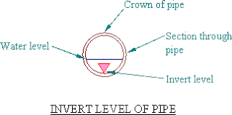 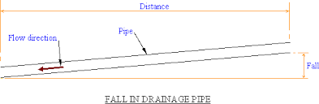

Figure: 3.4: Fall in Drainage Pipe

Figure: 3.3: Invert Level of Pipe

Table 4.1, shows the calculated result of total discharge per catchment area. ${ Q}_{wwf}$ is the discharge of the wet whether flow which have been calculated using rainfall intensity by rational method [4]. $Q_{dwf}$ is the discharge of dry whether flow which have been calculated using population in the respective catchment area. And for finding the peak flow peak coefficient has to be considered. As standard peak coefficient of 3 has been considered.

Table: 4.1: Total discharge per catchment area.

|  |  |  |  |  |  |  |  |
| --- | --- | --- | --- | --- | --- | --- | --- |
| CATCHMENT  NO. | AREA  (HECTORS) | LENGTH  (M) | H  (M) | $$t_{c}$$ hour | $$I_{c}$$ $${mm}/{hour}$$ | $Q_{wwf}$ (LPS) | $Q_{dwf}$ peak  (LPS) |
| 1 | 1.08 | 145.24 | 0.24 | 0.177 | 130.45 | 273.945 | 2.475 |
| 2 | 0.42 | 100.98 | 0.06 | 0.198 | 128.16 | 104.664 | 1.436 |
| 3 | 0.21 | 87.68 | 0.5 | 0.074 | 142.96 | 58.375 | 0 |
| 4 | 0.16 | 40.61 | 4.73 | 0.0128 | 151.60 | 47.164 | 0.12 |
| 5 | 0.91 | 145.66 | 1.22 | 0.095 | 140.22 | 248.112 | 0.648 |
| 6 | 1.02 | 114.99 | 0.43 | 0.108 | 130.57 | 258.964 | 2.268 |
| 7 | 0.94 | 122.06 | 1.62 | 0.069 | 143.63 | 262.524 | 2.133 |
| 8 | 0.59 | 109.68 | 0.12 | 0.167 | 131.56 | 150.929 | 1.443 |
| 9 | 0.43 | 95.86 | 1.4 | 0.055 | 145.54 | 121.687 | 0.768 |
| 10 | 0.63 | 141.96 | 0.82 | 0.107 | 138.69 | 169.89 | 1.455 |
| 11 | 0.34 | 57.16 | 0.32 | 0.054 | 145.54 | 96.304 | 0.987 |
| 12 | 0.55 | 131.13 | 2.97 | 0.054 | 145.67 | 155.048 | 1.296 |
| 13 | 0.68 | 81.02 | 0.31 | 0.082 | 141.90 | 187.629 | 0.96 |
| 14 | 0.86 | 101.78 | 1.22 | 0.063 | 144.44 | 241.536 | 1.26 |
| 15 | 1.33 | 153.39 | 3.25 | 0.069 | 143.63 | 337.443 | 4.323 |
| 16 | 0.89 | 136.114 | 2 | 0.073 | 143.09 | 247.625 | 3.63 |
| 17 | 0.33 | 68.34 | 1.2 | 0.039 | 147.78 | 94.82 | 0.15 |
| 18 | 0.56 | 123.90 | 0.44 | 0.116 | 137.58 | 149.809 | 1.518 |
| 19 | 0.92 | 172.99 | 0.42 | 0.174 | 130.78 | 233.951 | 3.525 |
| 20 | 0.92 | 102.24 | 0.64 | 0.082 | 141.90 | 253.84 | 0.636 |
| 21 | 0.24 | 80.13 | 4.13 | 0.029 | 149.21 | 69.63 | 1.125 |
| 22 | 0.33 | 99.35 | 1 | 0.066 | 144.03 | 92.419 | 1.275 |
| 23 | 0.18 | 129.77 | 0.12 | 0.202 | 127.74 | 44.709 | 0.75 |

Table:4.2, shows the calculated result of pipe slope($S_{S}$), diameter of pipe (D) and the thickness of pipe, taken from Indian standard code which depends upon the diameter [5]. As it can be seen that there are total number of 84 pipe lines and the total length of the pipe line which have been calculated as 2350m. The table also shows the upward and downward Ground level as well as Inverted level.

Table: 4.1: Pipe Dimensions

|  |  |  |  |  |  |  |  |  |  |
| --- | --- | --- | --- | --- | --- | --- | --- | --- | --- |
| Pipe  No. | Length  (M) | Total  Discharge (lps) | $$S_{s}$$ | Diameter  in meter | Thickness  in meter | Ground level (meter) | | Invert level (meter) | |
| Upward | Downward | Upward | Downward |
| 1 | 30 | 106.1 | 0.00241 | 0.45 | 0.075 | 14.67 | 14.583 | 14.145 | 14.058 |
| 2 | 30 | 106.1 | 0.00241 | 0.45 | 0.075 | 14.583 | 14.493 | 14.058 | 13.968 |
| 3 | 30 | 382.52 | 0.00102 | 0.8 | 0.095 | 14.493 | 14.456 | 13.598 | 13.561 |
| 4 | 30 | 382.52 | 0.00102 | 0.8 | 0.095 | 14.4561 | 14.4192 | 13.5611 | 13.5242 |
| 5 | 30 | 382.52 | 0.00102 | 0.8 | 0.095 | 14.4192 | 14.3823 | 13.5242 | 13.4873 |
| 6 | 30 | 534.829 | 0.000815 | 0.9 | 0.1 | 14.3823 | 14.3529 | 13.3823 | 13.3524 |
| 7 | 30 | 534.892 | 0.000815 | 0.9 | 0.1 | 14.3529 | 13.3235 | 13.3529 | 12.3235 |
| 8 | 30 | 657.347 | 0.000716 | 1 | 0.115 | 13.3235 | 12.2977 | 12.2085 | 11.1827 |
| 9 | 30 | 657.347 | 0.000716 | 1 | 0.115 | 12.2719 | 12.2461 | 11.1827 | 11.1569 |
| 10 | 30 | 657.347 | 0.000716 | 1 | 0.115 | 12.2719 | 12.2461 | 11.1569 | 11.1311 |
| 11 | 30 | 657.347 | 0.000652 | 1 | 0.115 | 12.2461 | 12.22261 | 11.1311 | 11.10761 |
| 12 | 30 | 925.983 | 0.000568 | 1.2 | 0.12 | 12.22261 | 12.20212 | 10.9026 | 10.88281 |
| 13 | 30 | 925.983 | 0.000568 | 1.2 | 0.12 | 12.20212 | 12.18163 | 10.88212 | 1086163 |
| 14 | 30 | 97.291 | 0.00255 | 0.4 | 0.075 | 13 | 12.9082 | 12.525 | 12.4332 |
| 15 | 15 | 97.291 | 0.00255 | 0.4 | 0.075 | 12.9082 | 12.847 | 12.4332 | 12.4395 |
| 16 | 30 | 97.291 | 0.00255 | 0.4 | 0.075 | 12.847 | 11.7552 | 12.372 | 11.2802 |
| 17 | 15 | 97.291 | 0.00255 | 0.4 | 0.075 | 11.7552 | 11.7449 | 11.28-2 | 11.2699 |
| 18 | 30 | 925.983 | 0.000568 | 1.2 | 0.12 | 12.1816 | 12.16114 | 10.18163 | 10.84114 |
| 19 | 30 | 925.983 | 0.000568 | 1.2 | 0.12 | 12.16114 | 12.14065 | 10.84114 | 10.82065 |
| 20 | 30 | 925.983 | 0.000568 | 1.2 | 0.12 | 12.14065 | 11.58016 | 10.82065 | 10.26016 |
| 21 | 15 | 925.983 | 0.000568 | 1.2 | 0.12 | 11.58016 | 10.79426 | 10.22016 | 9.47426 |
| 22 | 30 | 477.208 | 0.000883 | 0.9 | 0.1 | 10.79426 | 10.02576 | 9.79426 | 9.02576 |
| 23 | 15 | 1177.208 | 0.000516 | 1.4 | 0.135 | 10.02576 | 10.01646 | 8.49076 | 8.48146 |
| 24 | 15 | 1177.208 | 0.000516 | 1.4 | 0.135 | 10.0646 | 9.67846 | 8.48146 | 8.14346 |
| 25 | 15 | 1333.552 | 0.000416 | 1.6 | 0.14 | 9.67846 | 9.28046 | 7.93846 | 7.54046 |
| 26 | 30 | 1333.552 | 0.000416 | 1.6 | 0.15 | 9.28046 | 7.49436 | 7.54046 | 5.75436 |
| 27 | 30 | 1333.552 | 0.000416 | 1.6 | 0.14 | 7.49436 | 5.40876 | 5.75436 | 3.66876 |
| 28 | 30 | Min Flow | 0.000416 | 1.6 | 0.14 | - | - | - | - |
| 29 | 30 | Min Flow | 0.000416 | 1.6 | 0.14 | - | - | - | - |
| 30 | 15 | 246.657 | 0.00137 | 0.3 | 0.04 | 13 | 12.9715 | 12.6315 | 12.6325 |
| 31 | 30 | 246.657 | 0.00137 | 0.3 | 0.04 | 12.9715 | 12.612 | 12.6313 | 12.308 |
| 32 | 30 | 246.657 | 0.00137 | 0.3 | 0.04 | 12.612 | 12.2225 | 11.8825 | 11.8825 |
| 33 | 20 | 246.657 | 0.00137 | 0.3 | 0.04 | 12.225 | 9.623 | 11.8825 | 9.283 |
| 34 | 30 | 246.657 | 0.00137 | 0.3 | 0.04 | 9.263 | 7.1335 | 9.283 | 6.7935 |
| 35 | 30 | 246,657 | 0.00137 | 0.3 | 0.04 | 7.1335 | 4.2161 | 6.7935 | 3.5761 |
| 36 | 30 | 58.375 | 0.00381 | 0.08 | 0.025 | 14.67 | 13.6726 | 14.565 | 12.8476 |
| 37 | 30 | 58.375 | 0.00381 | 0.08 | 0.025 | 13.6726 | 13.0178 | 13.5676 | 12.9128 |
| 38 | 30 | 58.375 | 0.00381 | 0.08 | 0.025 | 13.0178 | 12.0604 | 12.9128 | 11.9554 |
| 39 | 30 | 58.375 | 0.00381 | 0.08 | 0.025 | 12.0604 | 8.873 | 11.9554 | 8.768 |
| 40 | 30 | 261.25 | 0.00141 | 0.3 | 0.04 | 11.94 | 11.8893 | 11.6 | 11.7843 |
| 41 | 30 | 261.25 | 0.00141 | 0.3 | 0.04 | 11.8893 | 11.6286 | 11.5493 | 11.2093 |
| 42 | 30 | 261.25 | 0.00141 | 0.3 | 0.04 | 11.6286 | 11.2579 | 11.2886 | 10.9179 |
| 43 | 30 | 261.25 | 0.00141 | 0.3 | 0.04 | 11.2579 | 10.7272 | 10.9173 | 10.3872 |
| 44 | 30 | 261.25 | 0.00141 | 0.3 | 0.04 | 10.7272 | 9.3965 | 10.3872 | 9.0565 |
| 45 | 30 | 319.625 | 0.00116 | 0.35 | 0.075 | 9.3965 | 8.7348 | 8.715 | 8.3098 |
| 46 | 30 | 319.625 | 0.00116 | 0.35 | 0.075 | 8.7348 | 7.2431 | 8.3098 | 6.8181 |
| 47 | 30 | 45.459 | 0.00425 | 0.08 | 0.025 | 13.09 | 12.937 | 12.985 | 12.832 |
| 48 | 30 | 45.459 | 0.00425 | 0.08 | 0.025 | 12.937 | 12.784 | 12.832 | 12.679 |
| 49 | 15 | 45.459 | 0.00425 | 0.08 | 0.025 | 12.784 | 12.631 | 12.678 | 12.531 |
| 50 | 20 | 151.327 | 0.00191 | 0.2 | 0.17 | 12.57 | 12.53565 | 12.2 | 12.16565 |
| 51 | 30 | 151.327 | 0.00191 | 0.2 | 0.17 | 12.53565 | 12.4898 | 12.1656 | 12.1198 |
| 52 | 30 | 151.327 | 0.00191 | 0.2 | 0.17 | 12.4898 | 12.4215 | 12.1198 | 12.0515 |
| 53 | 20 | 196.786 | 0.00159 | 0.225 | 0.03 | 12.631 | 12.5734 | 12.376 | 12.3184 |
| 54 | 30 | 196.786 | 0.00159 | 0.225 | 0.03 | 12.5734 | 12.155 | 12.3184 | 11.9 |
| 55 | 30 | 196.786 | 0.00159 | 0.225 | 0.03 | 12.155 | 12.0974 | 11.9 | 11.8424 |
| 56 | 10 | 291.756 | 0.00123 | 0.35 | 0.075 | 12.0974 | 11.033 | 11.6724 | 10.608 |
| 57 | 30 | 291.756 | 0.00123 | 0.35 | 0.075 | 11.033 | 10.2482 | 10.628 | 9.8232 |
| 58 | 30 | 291.756 | 0.00123 | 0.35 | 0.075 | 10.2483 | 9.4138 | 9.8232 | 8.9888 |
| 59 | 30 | 291.756 | 0.00123 | 0.35 | 0.075 | 9.4138 | 7.6994 | 8.9888 | 7.274 |
| 60 | 30 | 667.522 | 0.000701 | 0.8 | 0.025 | 7.6994 | 5.8439 | 6.8744 | 5.0189 |
| 61 | 30 | 237.476 | 0.00141 | 0.3 | 0.04 | 13.09 | 13.0393 | 12.75 | 12.6993 |
| 62 | 30 | 237.476 | 0.00141 | 0.3 | 0.04 | 13.0393 | 12.5683 | 12.6993 | 12.2283 |
| 63 | 30 | 331.17 | 0.00132 | 0.7 | 0.087 | 12.5683 | 10.9878 | 11.7833 | 10.2028 |
| 64 | 30 | 331.17 | 0.00132 | 0.7 | 0.087 | 10.9878 | 9.567 | 10.2028 | 8.78 |
| 65 | 30 | 331.17 | 0.00132 | 0.7 | 0.087 | 9.567 | 7.3362 | 8.782 | 6.5512 |
| 66 | 30 | 401.926 | 0.00099 | 0.8 | 0.097 | 7.3362 | 5.5087 | 6.4412 | 4.6137 |
| 67 | 30 | 319.625 | 0.00116 | 0.7 | 0.087 | 7.2431 | 6.3314 | 6.4581 | 5.5464 |
| 68 | 30 | 319.625 | 0.00116 | 0.7 | 0.087 | 6.3314 | 5.7197 | 5.464 | 5.9347 |
| 69 | 30 | 319.625 | 0.00116 | 0.7 | 0.087 | 5.7197 | 5.678 | 4.9347 | 4.893 |
| 70 | 30 | 568.393 | 0.00078 | 1 | 0.115 | 5.678 | 5.6496 | 4.563 | 4.5346 |
| 71 | 30 | 568.393 | 0.00078 | 1 | 0.115 | 5.6496 | 5.29124 | 4.5346 | 4.17624 |
| 72 | 30 | 568.393 | 0.00078 | 1 | 0.115 | 5.29124 | 4.9328 | 4.17624 | 3.8174 |
| 73 | 30 | 568.393 | 0.00078 | 1 | 0.115 | 4.9328 | 4.5744 | 3.8178 | 3.4594 |
| 74 | 30 | 756.982 | 0.00649 | 1 | 0.115 | 4.5744 | 4.22108 | 3.4594 | 3.1068 |
| 75 | 30 | 1003.639 | 0.000539 | 1.4 | 0.135 | 4.22108 | 4.20164 | 2.68608 | 2.66664 |
| 76 | 30 | 1246.435 | 0.000467 | 1.4 | 0.135 | 4.20164 | 4.1848 | 2.66664 | 2.6498 |
| 77 | 30 | 1246.435 | 0.000467 | 1.4 | 0.135 | 4.1848 | 4.16798 | 2.6498 | 2.63248 |
| 78 | 15 | 1246.435 | 0.000467 | 1.4 | 0.135 | 4.16798 | 4.14954 | 2.63208 | 2.62458 |
| 79 | 30 | 2579.985 | 0.000287 | 2 | 0.17 | 4.15954 | 4.14923 | 1.98958 | 1.98923 |
| 80 | 30 | 2579.985 | 0.000287 | 2 | 0.17 | 4.14923 | 4.13888 | 1.97923 | 1.9688 |
| 81 | 30 | 2579.985 | 0.000287 | 2 | 0.17 | 4.13888 | 4.12853 | 1.96888 | 1.95853 |
| 82 | 30 | 3247.509 | 0.000246 | 2.4 | 0.2 | 4.12853 | 4.11965 | 1.52853 | 1.51961 |
| 83 | 30 | 3247.509 | 0.000246 | 2.4 | 0.2 | 4.11965 | 4.11077 | 1.51965 | 1.51077 |
| 84 | 30 | 3501.985 | 0.000235 | 2.4 | 0.2 | 4.11077 | 4.10231 | 1.51077 | 1.5032 |

**CONCLUSION**

This paper gives the details about design of sewer system using rational method with the help of EPANET software. The maximum rainfall intensity is also been calculated for every catchment area. After carrying out the study it has been observed that there are no pumps required the flow in accordance with the elevation. In the design of sewer it can clearly be seen that discharge is varying at different catchment and this is clearly due to variation of population and difference in catchment area. The material used in sewers should be non corrosive. The slope of the pipe is maintained in downward direction to maintain the steady flow. The length of the sewer pipe is 2350 meters and the diameter and thickness of the sewer vary every 30 meter as per the requirement to reduce the cost of the project. The proper design of Sewerage system ensures the friendly environment and the water in the area will also be pollution free to some extent and hence health related issues resulting due to pollution and water will also decrease.

**REFERENCE**

1. Bowman, J.J., Lough Ree: 1996. An investigation of eutrophication and its causes, Environmental Protection Agency.

2. Crabtree, R.W., (1989). “Sediment in sewers” J. Inst. Water Managem, 3, 569-578

3. Esen, I.I.,(1993). “ Design of sewers based on minimum velocity.” J. Env. Eng., 119(3)

4. Manual on Sewerage and Sewage Treatment Central Public Health and Environmental Engineering Organization Ministry of Urban Development New Delhi in Collaboration with Japan International Cooperation Agency

5. Yao, K.M., (1974). “ Sewer line design based on critical shear stress.” J. Env. Eng., 100(EE2)

6. Zhang. J..(2001). “Modern concept of city sewerage system.” China.3 (10). 33-5